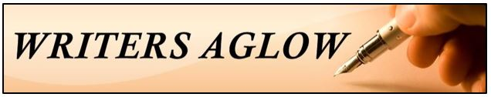
Preparing work for Critique
Zoom Calls
- 1500 words maximum
- Times New Roman 14 point font
- Double Spaced
- Number the lines
Work will look like this:

